TASK ONE
class HeyDhena
{

public static void main(String[] args)
{

System.out.print("Hey, Dhena!");
System.out.print("My Name Is Dhena.");
System.out.print("I am 18 years old.");
System.out.print("I study at Matriculation.");
System.out.print("My IC number is 000122100940.");
}
}

TASK TWO
class DisplayMessages
{
public static void main(String[] args)
{
System.out.print("I Like Computer Science.");
System.out.print("I Love Programming.");
System.out.print("I Learn Java.");
}
}

class DisplayMessages1
{
public static void main(String[] args)
{
System.out.println("I Like Computer Science.");
System.out.println("I Love Programming.");
System.out.println("I Learn Java.");
}
}

class DisplayMessages2
{
public static void main(String[] args)
{
System.out.print("\nI Like Computer Science.");
System.out.print("\nI Love Programming.");
System.out.print("\nI Learn Java.");
}
}

TASK THREE
class DisplayMessages3
{
public static void main(String[] args)
{
System.out.print("\nI Like Computer Science.");
System.out.print("\n\tI Love Programming.");
System.out.print("\n\t\tI Learn Java.");
}
}

TASK FOUR
class DisplayKMPh1
{
public static void main(String[] args)
{
System.out.println("Kolej Matrikulasi Pahang.");
System.out.println("Kementerian Pendidikan Malaysia.");
System.out.println("26300, Gambang.");
}
}

class DisplayKMPh2
{
public static void main(String[] args)
{
System.out.print("\n\t\tI Like Computer Science.");
System.out.print("\n\tI Love Programming.");
System.out.print("\nI Learn Java.");
}
}

class DisplayDhena
{
public static void main(String[] args)
{
System.out.print("\nMy name is Dhena.");
System.out.print("\n\tI am 18 years old yay.");
System.out.print("\nI target 4.0 hopefully for finals.");
System.out.print("\n\tToday date is Monday of November, 2018.");
}
}

class DisplayIntegers1{
public static void main(String[] args){
System.out.print("\n0 2 4 6 8 is even numbers less than 10.");
System.out.print("\n11 13 15 17 19 is odd numbers between 10 and 20.");
}
}

class DisplayIntegers2{
public static void main(String[] args){
System.out.print("\n1 2 3 4 5 is positive integers less than 6.");
System.out.print("\n-1 -2 -3 -4 -5 is negative integers greater than -6");
}
}

PRACTICAL TWO
Task one
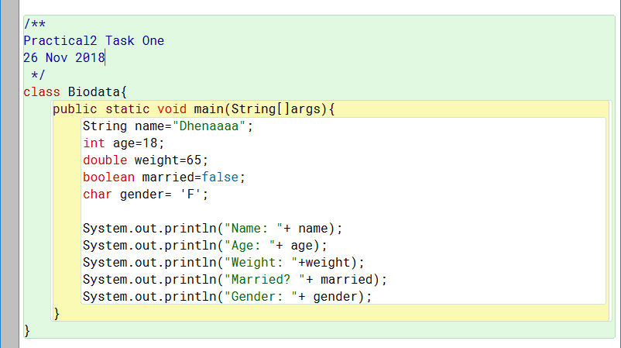

Task two
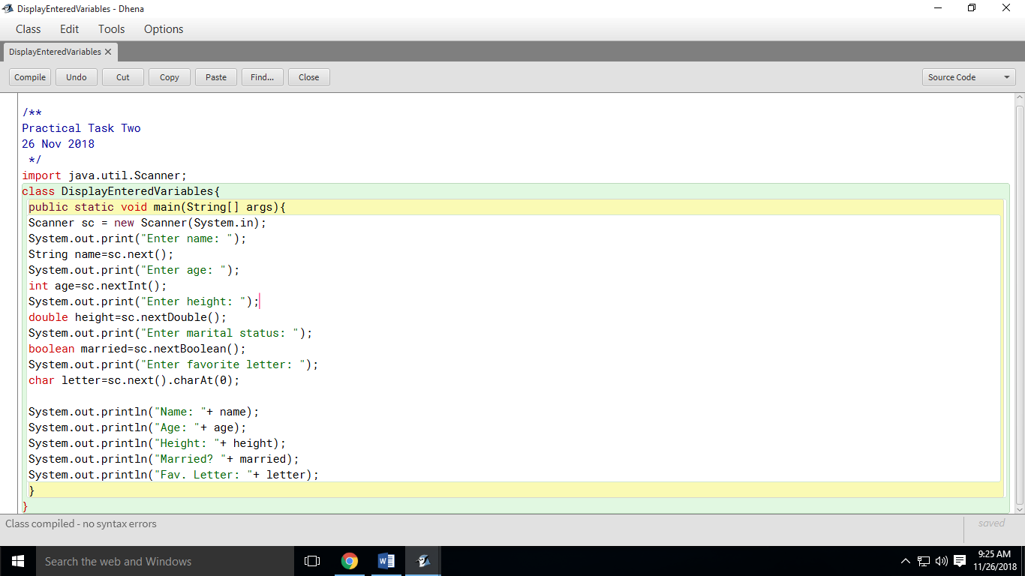

Task three

Task Four

Task Five

